Public Service Authority Evaluation and Recommendation Committee
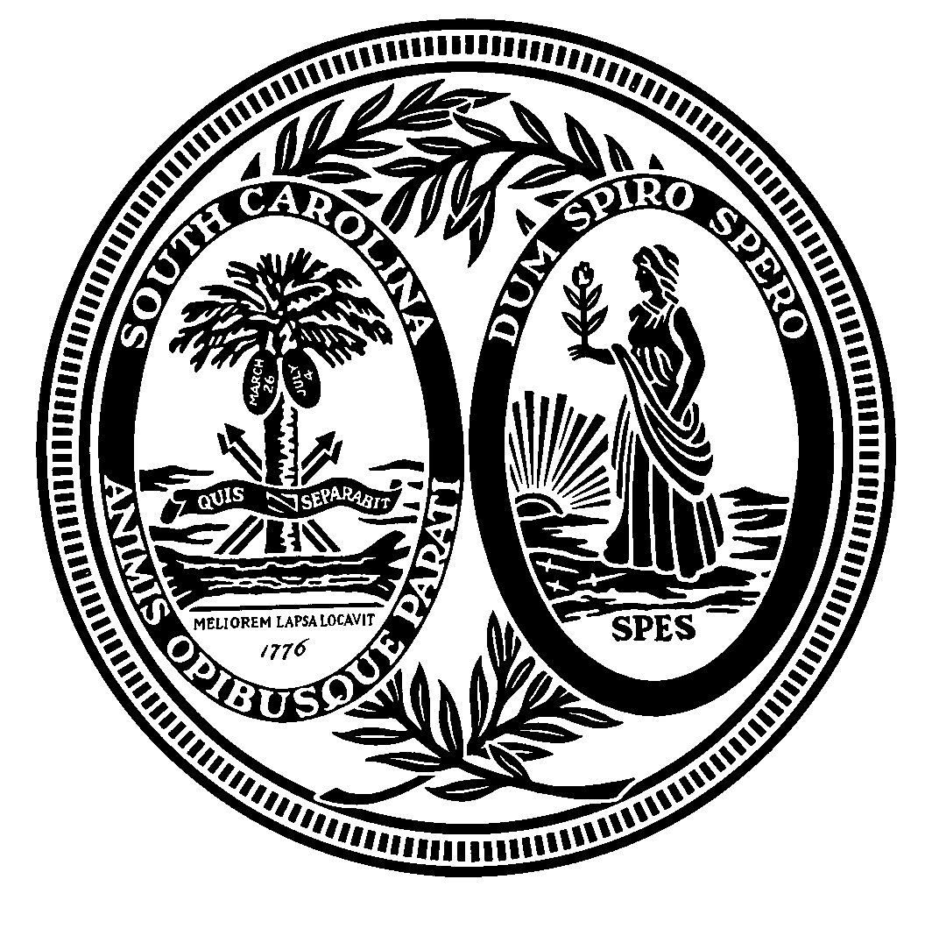

Senator Paul G. Campbell, Jr., Co-Chairman
Representative G. Murrell Smith, Jr., Co-Chairman
Senator Tom Davis
Representative Russell W. Fry
Senator Lawrence K. “Larry” Grooms
Senator Bradley Hutto
Representative Peter M. McCoy, Jr.
Governor Henry McMaster
Representative Russell L. Ott

Post Office Box 142
Columbia, South Carolina 29202

Agenda

Wednesday, October 17, 2018
11:00 a.m.
Room 110, Blatt Building

I. ICF Presentation

II. Electric Cooperatives Presentation

III. Adjournment

